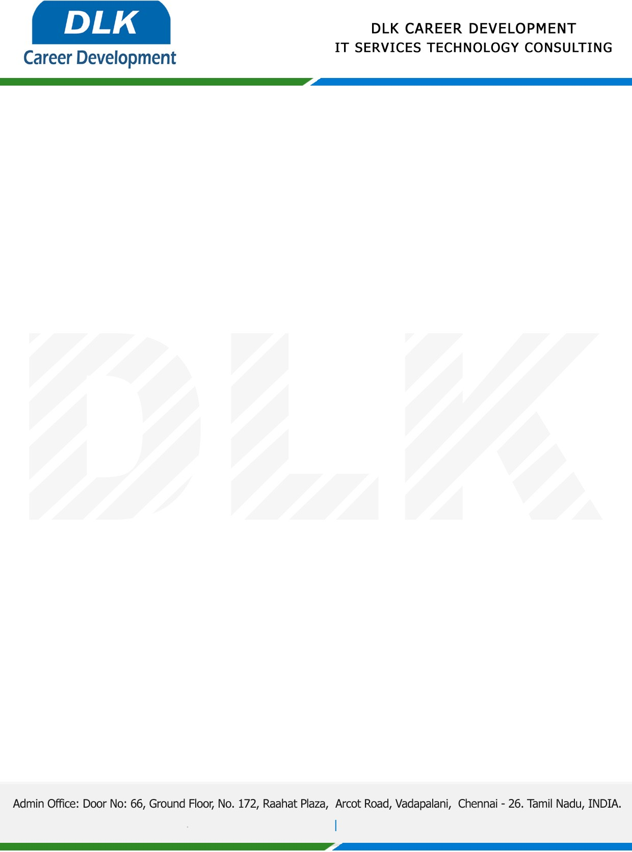

Date: 28 /January/ 2023

**To**

Department of MCA [,](https://www.cseindia.org/)

Head of Department,

Vels University, Chennai - 600117.

**Sub: Letter of Project Acceptance**

This is to certify that **MR ABISHEK RAJ D Y (REG NO: 21222118)** final year student of has accepted the Project Work duration from **01th** **February 2023** to **02nd June 2023** under the domain **“Java”.** During the Project, all information and data collected from you should be kept confidential.

**Topic:** Blockchain Based Accounts Payable Platform for Goods Trade

We appreciate your interest in **DLK CAREER DEVELOPMENT**

